Case 6-Afr-Mali-Dogon-Kanaga Masked Dancer-Bronze-8.5 in

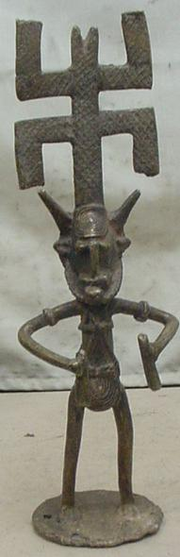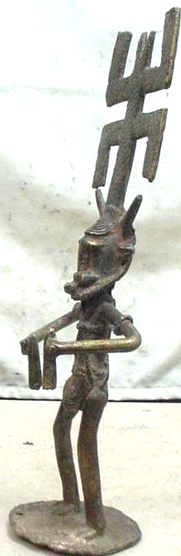

Case no.:

Accession Number:

Formal Label:

**Display Description:**

* Kananga masks form geometric patterns. These masks represent the first human beings and are normally made by carvers of the Awa society. The masks are worn during the Dama dancing ceremonies The Dogon believe that the Dama dance creates a bridge into the supernatural world. Without the Dama dance, the dead cannot cross over into peace.

Typical characteristic of this mask is the dual cross with short bars extending up across the top piece and down on the bottom piece. The top portion of the vertical bar sometimes bear an animal, human or abstract figure. The masks are normally painted white and black. Common features are the rectangular face, thin long nose and large eyeholes.

**LC Classification: GN419.5**

Date or Time Horizon:

Geographical Area:

**Map:**

**GPS coordinates:**

Cultural Affiliation:

Media:

Dimensions:

Weight:

Condition:

Provenance:

**Discussion:**

* Every five years, Dama memorial ceremonies are held to accompany the dead into the ancestral realm and restore order to the universe. During the Dama celebration, Youdiou villagers circle around stilt dancers. The dance and costumes imitate a long-legged water bird. The dancers execute difficult steps while teetering high above the crowd. Through such rituals, the Dogon believe that the benevolent force of the ancestor is transmitted to them.

**References:**

*Visual tropes: the kanaga mask of the Dogon people of West Africa*

by Michael DeHart Harris

 Thesis/dissertation : Thesis/dissertation : Manuscript  Archival Material

Language: English

Publisher: 1989.

*Masques dogons.*

Author

[Griaule, Marcel](https://buprimo.hosted.exlibrisgroup.com/primo-explore/search?query=creator%2Cexact%2CGriaule%2C Marcel%2CAND&sortby=rank&vid=BU&lang=en_US&mode=advanced)

Subjects

[Dogon (African people)](https://buprimo.hosted.exlibrisgroup.com/primo-explore/search?query=sub%2Cexact%2CDogon (African people)%2CAND&sortby=rank&vid=BU&lang=en_US&mode=advanced)

[Masks, African](https://buprimo.hosted.exlibrisgroup.com/primo-explore/search?query=sub%2Cexact%2C Masks%2C African%2CAND&sortby=rank&vid=BU&lang=en_US&mode=advanced)

[Dogon](https://buprimo.hosted.exlibrisgroup.com/primo-explore/search?query=sub%2Cexact%2C Dogon%2CAND&sortby=rank&vid=BU&lang=en_US&mode=advanced)

Related Titles

**Series:** : Université de Paris. Travaux et mémoires de l'Institut d'ethnologie.--XXXIII.